**WARNINGS AND PROMPTS**

**Performed steps**

1. Open up simulation.
2. Insert variables.
3. Compare results with expected results from “test plan”.

**Results**

This is the result with the simulation when a numeric value is inserted:

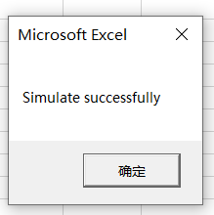

This is the result with the simulation when a non-numeric value is inserted:

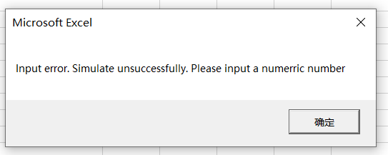

**Conclusion**

In conclusion, the outputs from the simulation match the outputs from the calculations. Therefore, the hypothesis:

*“Warnings and prompts appear on the right time when simulations are failed or successful.”*

is correct and the simulation works as intended.